**Cuprins:**

Task: ……………………………………………………………………………………...3

Imagini:……………………………………………………………………………………4

Codul sursa:………………………………………………………………………………10

Functionalitate:…………………………………………………………………………...49

Imaginile folosite…………………………………………………………………………53

**Task**

Creati o aplicatie functionala in Android Studio care sa contina informatii, imagini, link-uri, etc. legate de

***virusul Covid-19***. Proiectul trebuie sa contina cat mai multe din *mijloacele*:

1. Cel putin trei activitati

2. Imagini incarcate de pe Internet si local

3. Acces Internet (incarcarea cel putin a unei pagini web)

4. Liste care contin informatii detaliate la activarea componentelor (itemi)

5. Baza de date cu pentru stocarea informatiilor (centre de testare, adrese, email, tel)

6. Sistem login

7. Butoane

8. Formular de introducere a datelor (persoane pentru testere-programate, rezultat etc.)

9. Galerie foto (centre testare, etc.)

10. Chestionar



**Imagini**

MainActivity:

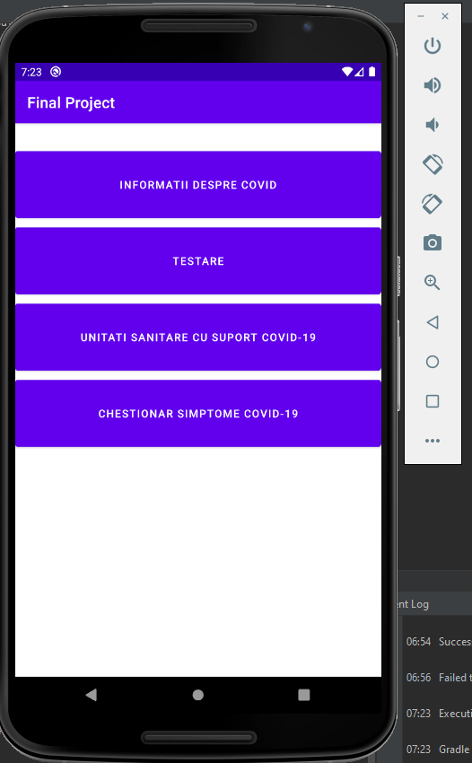

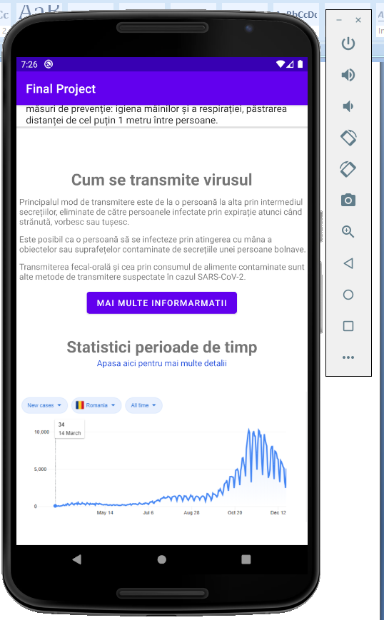Informatii:

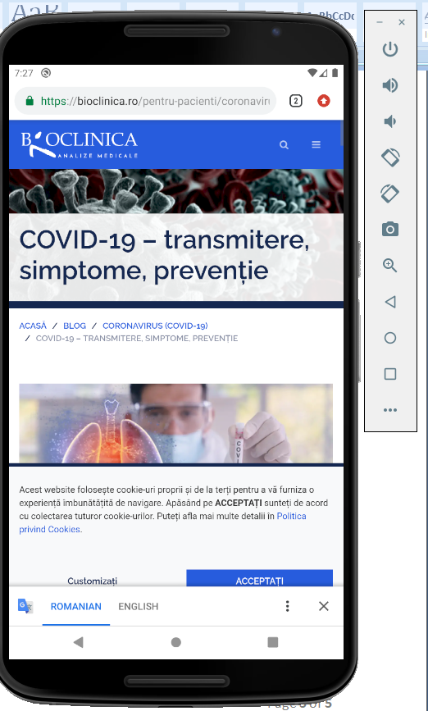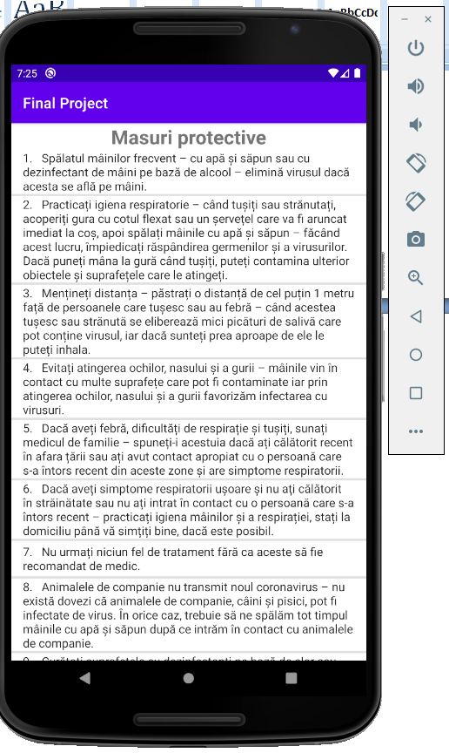

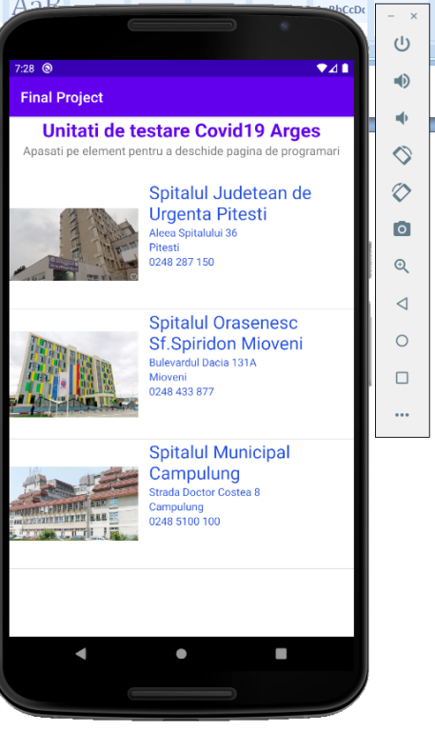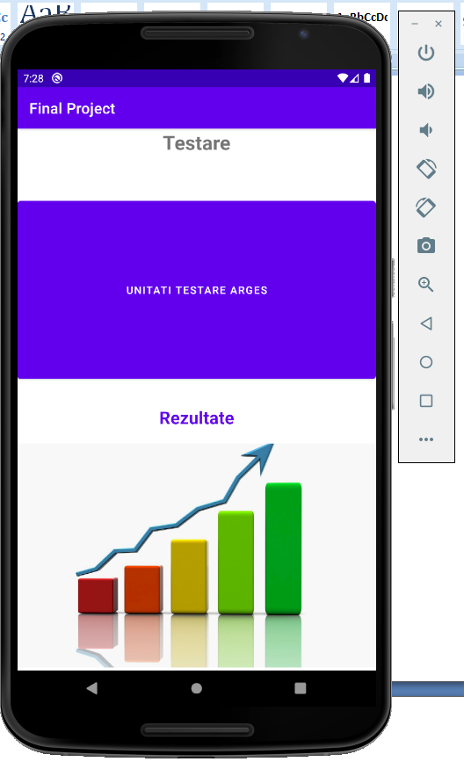Test: Unitati testare:

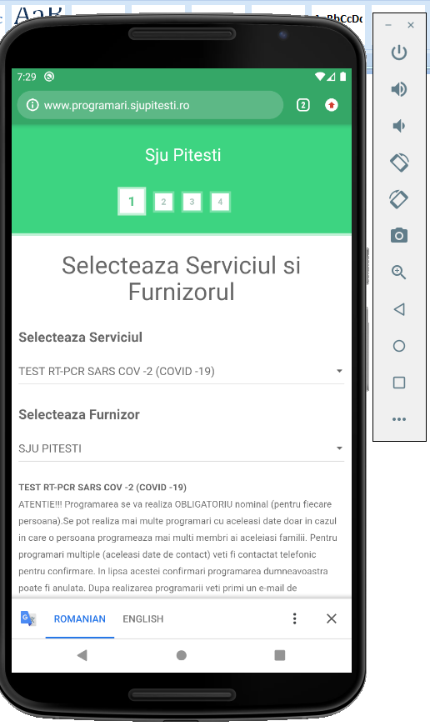Programare: Logare:

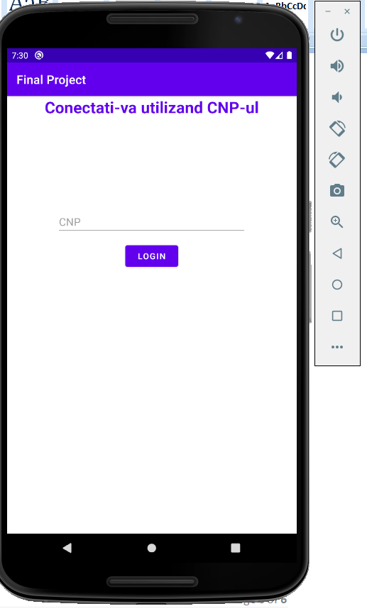

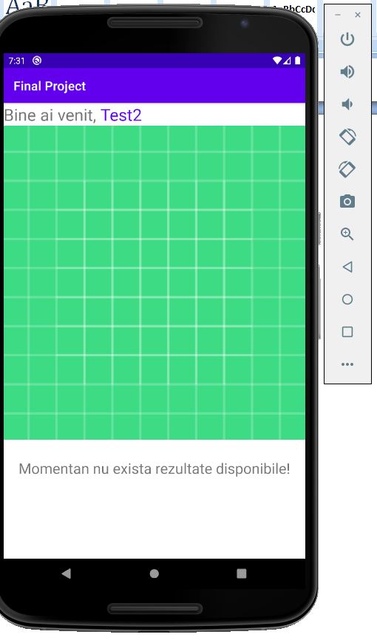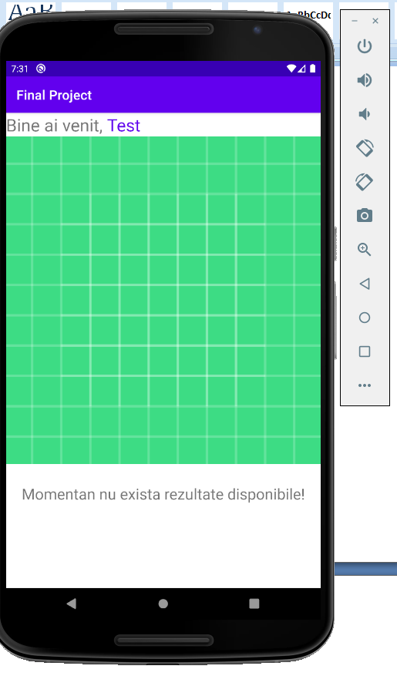Utilizator 1 logat: Utilizator 2 logat:

Utilizator 3 logat:

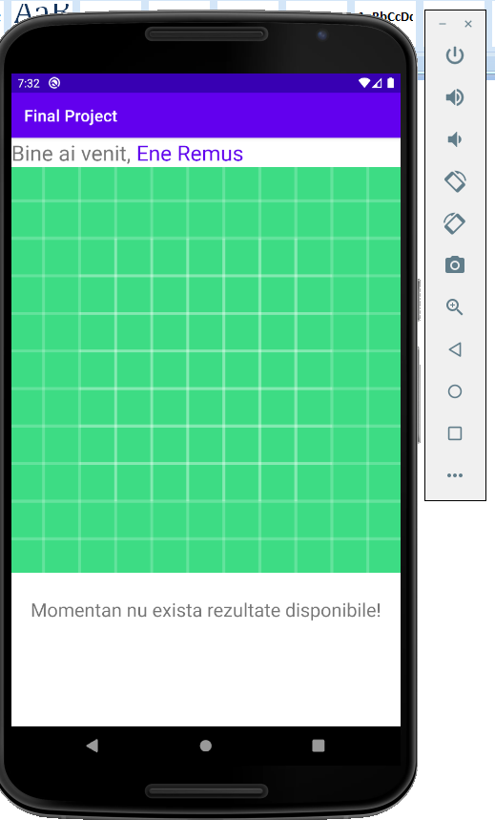

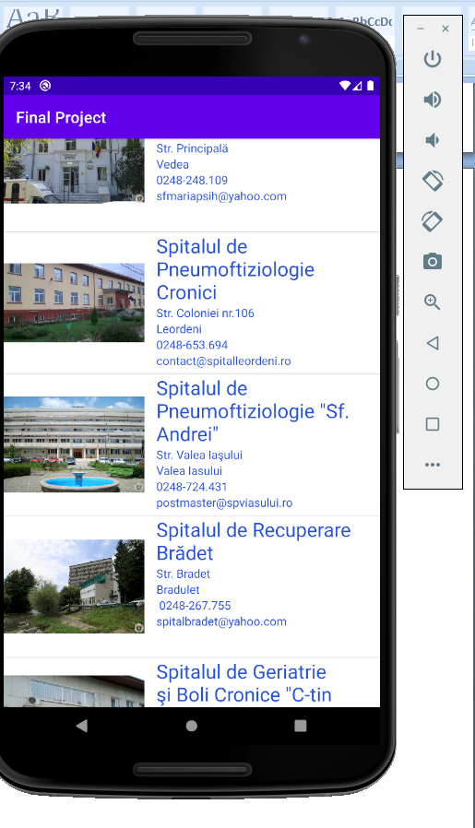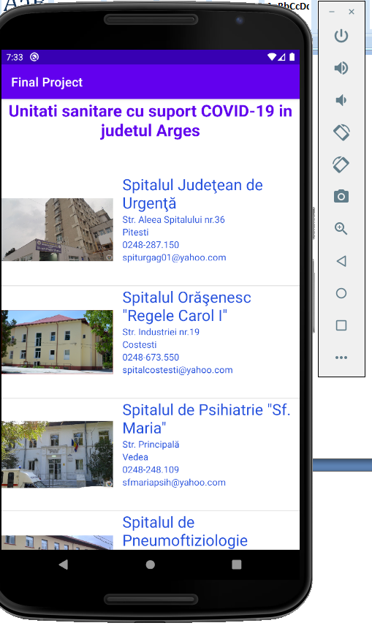Unitati:

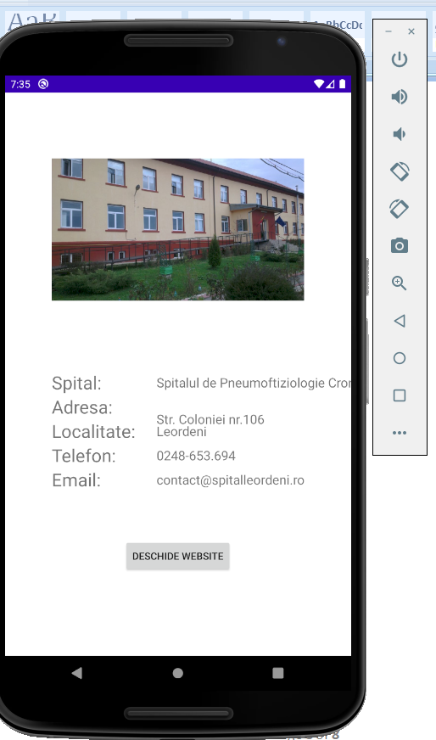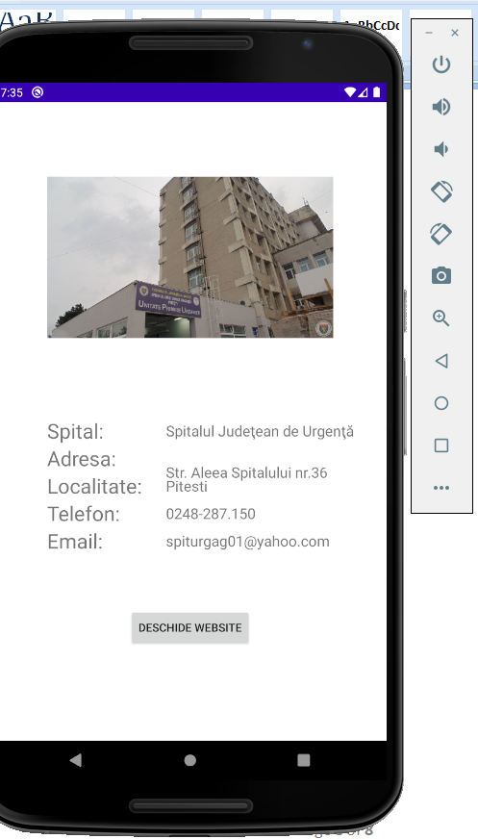

Chestionar:

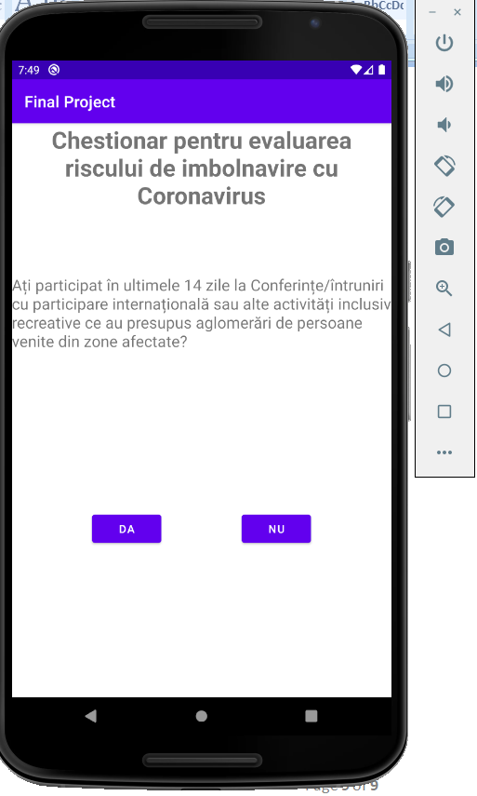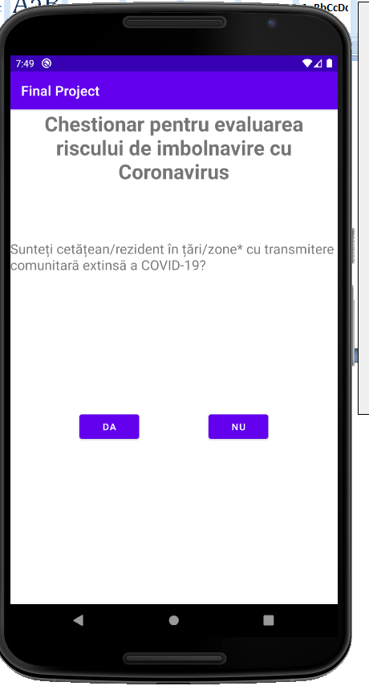

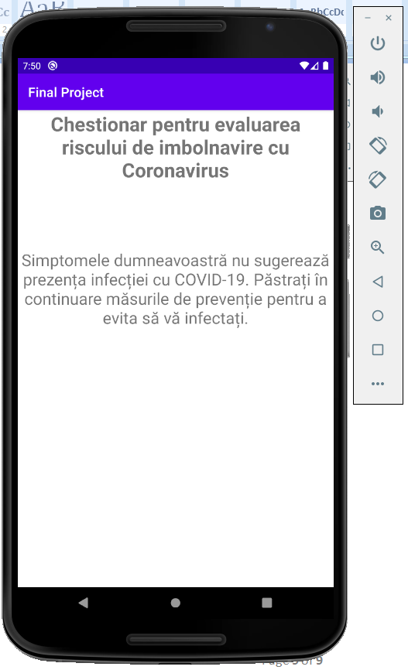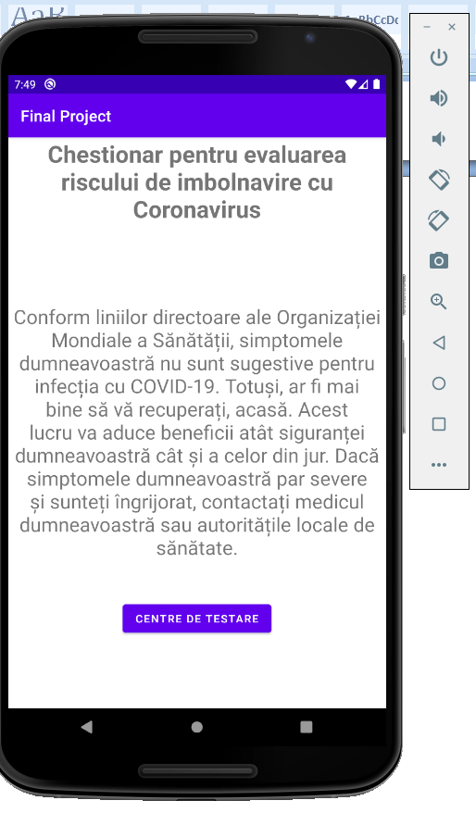

**Codul sursa**

activity_main.xml :

<?xml version="1.0" encoding="utf-8"?>  
<androidx.constraintlayout.widget.ConstraintLayout xmlns:android="http://schemas.android.com/apk/res/android"  
 xmlns:app="http://schemas.android.com/apk/res-auto"  
 xmlns:tools="http://schemas.android.com/tools"  
 android:layout_width="match_parent"  
 android:layout_height="match_parent"  
 tools:context=".MainActivity">  
  
 <Button  
 android:id="@+id/covidInfo"  
 android:layout_width="match_parent"  
 android:layout_height="100dp"  
 android:text="Informatii despre covid"  
 app:layout_constraintTop_toTopOf="parent"  
 app:layout_constraintLeft_toLeftOf="parent"  
 app:layout_constraintRight_toRightOf="parent"  
 android:layout_marginTop="30dp"  
 />  
  
 <Button  
 android:id="@+id/covidTest"  
 android:layout_width="match_parent"  
 android:layout_height="100dp"  
 android:text="Testare"  
 app:layout_constraintTop_toBottomOf="@+id/covidInfo"  
 app:layout_constraintRight_toRightOf="parent"  
 app:layout_constraintLeft_toLeftOf="parent"  
 />  
  
 <Button  
 android:id="@+id/covidUnitati"  
 android:layout_width="match_parent"  
 android:layout_height="100dp"  
 android:text="Unitati sanitare cu suport covid-19"  
 app:layout_constraintTop_toBottomOf="@+id/covidTest"  
 app:layout_constraintLeft_toLeftOf="parent"  
 app:layout_constraintRight_toRightOf="parent"  
 />  
  
 <Button  
 android:id="@+id/covidChestionar"  
 android:layout_width="match_parent"  
 android:layout_height="100dp"  
 android:text="Chestionar simptome covid-19"  
 app:layout_constraintTop_toBottomOf="@+id/covidUnitati"  
 app:layout_constraintLeft_toLeftOf="parent"  
 app:layout_constraintRight_toRightOf="parent"  
 />  
  
</androidx.constraintlayout.widget.ConstraintLayout>

MainActivity.java :

package com.example.finalproject;  
  
import androidx.appcompat.app.AppCompatActivity;  
  
import android.content.Intent;  
import android.os.Bundle;  
import android.view.View;  
import android.widget.Button;  
  
public class MainActivity extends AppCompatActivity {  
  
 Button btnInfo,btnTest,btnUnitati,btnChestionar;  
  
 @Override  
 protected void onCreate(Bundle savedInstanceState) {  
 super.onCreate(savedInstanceState);  
 setContentView(R.layout.*activity_main*);  
  
 clickedButton();  
  
 }  
  
 public void clickedButton(){  
 btnInfo=(Button) findViewById(R.id.*covidInfo*);  
 btnTest=(Button) findViewById(R.id.*covidTest*);  
 btnUnitati=(Button) findViewById(R.id.*covidUnitati*);  
 btnChestionar=(Button) findViewById(R.id.*covidChestionar*);  
  
 btnInfo.setOnClickListener(new View.OnClickListener() {  
 @Override  
 public void onClick(View v) {  
 Intent i=new Intent(MainActivity.this,Information.class);  
 startActivity(i);  
 }  
 });  
  
 btnTest.setOnClickListener(new View.OnClickListener() {  
 @Override  
 public void onClick(View v) {  
 Intent i= new Intent(MainActivity.this,Test.class);  
 startActivity(i);  
 }  
 });  
  
 btnUnitati.setOnClickListener(new View.OnClickListener() {  
 @Override  
 public void onClick(View v) {  
 Intent i= new Intent(MainActivity.this,Unitati.class);  
 startActivity(i);  
 }  
 });  
  
 btnChestionar.setOnClickListener(new View.OnClickListener() {  
 @Override  
 public void onClick(View v) {  
 Intent i= new Intent(MainActivity.this,Chestionar.class);  
 startActivity(i);  
 }  
 });  
  
 }  
  
}

activity_information.xml :

<?xml version="1.0" encoding="utf-8"?>  
<ScrollView xmlns:android="http://schemas.android.com/apk/res/android"  
 xmlns:app="http://schemas.android.com/apk/res-auto"  
 xmlns:tools="http://schemas.android.com/tools"  
 android:layout_width="fill_parent"  
 android:layout_height="fill_parent"  
 tools:context=".Information">  
  
 <LinearLayout  
 android:layout_width="match_parent"  
 android:layout_height="match_parent"  
 android:orientation="vertical">  
  
 <TextView  
 android:layout_width="match_parent"  
 android:layout_height="wrap_content"  
 android:gravity="center_horizontal"  
 android:text="@string/infoTitle1"  
 android:textSize="80px" />  
  
 <ListView  
 android:id="@+id/measureList"  
 android:layout_width="match_parent"  
 android:layout_height="1000dp"  
 android:dividerHeight="3dp"  
 android:footerDividersEnabled="true"  
 android:headerDividersEnabled="true" />  
  
 <TextView  
 android:layout_width="match_parent"  
 android:layout_height="wrap_content"  
 android:layout_marginTop="30dp"  
 android:text="@string/infoTitle2"  
 android:gravity="center"  
 android:textSize="80px"  
 />  
 <TextView  
 android:layout_marginTop="10dp"  
 android:layout_marginLeft="5dp"  
 android:layout_width="match_parent"  
 android:layout_height="wrap_content"  
 android:text="@string/infoContent2.1"  
 android:textIsSelectable="true"  
 />  
 <TextView  
 android:layout_marginTop="10dp"  
 android:layout_marginLeft="5dp"  
 android:layout_width="match_parent"  
 android:layout_height="wrap_content"  
 android:text="@string/infoContent2.2"  
 android:textIsSelectable="true"/>  
  
 <TextView  
 android:layout_marginTop="10dp"  
 android:layout_marginLeft="5dp"  
 android:layout_marginBottom="10dp"  
 android:layout_width="match_parent"  
 android:layout_height="wrap_content"  
 android:text="@string/infoContent2.3"  
 android:textIsSelectable="true"/>  
  
 <Button  
 android:id="@+id/btnOnWeb"  
 android:layout_width="wrap_content"  
 android:layout_height="wrap_content"  
 android:text="Mai multe informarmatii"  
 android:layout_gravity="center" />  
  
 <TextView  
 android:layout_marginTop="30dp"  
 android:layout_width="match_parent"  
 android:layout_height="wrap_content"  
 android:text="@string/infoTitle3"  
 android:gravity="center"  
 android:textSize="80px"  
 />  
  
 <TextView  
 android:id="@+id/webStatistics"  
 android:layout_width="match_parent"  
 android:layout_height="wrap_content"  
 android:clickable="true"  
 android:text="Apasa aici pentru mai multe detalii"  
 android:gravity="center"  
 android:textColor="@color/blue"/>  
  
 <ImageView  
 android:id="@+id/statisticsPhoto"  
 android:layout_width="match_parent"  
 android:layout_height="wrap_content"  
 android:src="@drawable/covid"/>  
 </LinearLayout>  
  
</ScrollView>

package com.example.finalproject;  
  
import androidx.appcompat.app.AppCompatActivity;  
  
import android.content.Intent;  
import android.net.Uri;  
import android.os.Bundle;  
import android.view.View;  
import android.widget.ArrayAdapter;  
import android.widget.Button;  
import android.widget.ListView;  
import android.widget.TextView;  
  
public class Information extends AppCompatActivity {  
  
 String[] Measures={  
 "1. Spălatul mâinilor frecvent – cu apă și săpun sau cu dezinfectant de mâini pe bază de alcool – elimină virusul dacă acesta se află pe mâini.",  
 "2. Practicați igiena respiratorie – când tușiți sau strănutați, acoperiți gura cu cotul flexat sau un șervețel care va fi aruncat imediat la coș, apoi spălați mâinile cu apă și săpun – făcând acest lucru, împiedicați răspândirea germenilor și a virusurilor. Dacă puneți mâna la gură când tușiți, puteți contamina ulterior obiectele și suprafețele care le atingeți.",  
 "3. Mențineți distanța – păstrați o distanță de cel puțin 1 metru față de persoanele care tușesc sau au febră – când acestea tușesc sau strănută se eliberează mici picături de salivă care pot conține virusul, iar dacă sunteți prea aproape de ele le puteți inhala.",  
 "4. Evitați atingerea ochilor, nasului și a gurii – mâinile vin în contact cu multe suprafețe care pot fi contaminate iar prin atingerea ochilor, nasului și a gurii favorizăm infectarea cu virusuri.",  
 "5. Dacă aveți febră, dificultăți de respirație și tușiți, sunați medicul de familie – spuneți-i acestuia dacă ați călătorit recent în afara țării sau ați avut contact apropiat cu o persoană care s-a întors recent din aceste zone și are simptome respiratorii.",  
 "6. Dacă aveți simptome respiratorii ușoare și nu ați călătorit în străinătate sau nu ați intrat în contact cu o persoană care s-a întors recent – practicați igiena mâinilor și a respirației, stați la domiciliu până vă simțiți bine, dacă este posibil.",  
 "7. Nu urmați niciun fel de tratament fără ca aceste să fie recomandat de medic.",  
 "8. Animalele de companie nu transmit noul coronavirus – nu există dovezi că animalele de companie, câini și pisici, pot fi infectate de virus. În orice caz, trebuie să ne spălăm tot timpul mâinile cu apă și săpun după ce intrăm în contact cu animalele de companie.",  
 "9. Curățați suprafețele cu dezinfectanți pe bază de clor sau alcool – dezinfectanți ce conțin, clor, înnălbitori, solvent, etanol de 75%, acid paracetic și cloroform pot ucide noul coronavirus.",  
 "10. Evitați zonele aglomerate, mijloacele de transport în comun.",  
 "11. Alegeți să vă informați din surse oficiale.",  
 "12. Purtând o mască medicală (dacă avem simptome respiratorii) putem ajuta la împiedicarea răspândirii unor afecțiuni respiratorii. Totuși, doar această măsură nu garantează oprirea infecțiilor și ar trebui combinată cu celelalte măsuri de prevenție: igiena mâinilor și a respirației, păstrarea distanței de cel puțin 1 metru între persoane."  
 };  
  
 ListView lvMeasures;  
 Button btnWebInfo;  
 TextView statisticsRo;  
  
 @Override  
 protected void onCreate(Bundle savedInstanceState) {  
 super.onCreate(savedInstanceState);  
 setContentView(R.layout.*activity_information*);  
  
 setList();  
 webSearch();  
  
 }  
  
 public void setList(){  
 lvMeasures=findViewById(R.id.*measureList*);  
 ArrayAdapter<String> measuresAdapter=new ArrayAdapter<>(this,android.R.layout.*simple_list_item_1*,Measures);  
 lvMeasures.setAdapter(measuresAdapter);  
 }  
  
 public void webSearch(){  
 btnWebInfo=(Button) findViewById(R.id.*btnOnWeb*);  
 statisticsRo=(TextView) findViewById(R.id.*webStatistics*);  
  
 btnWebInfo.setOnClickListener(new View.OnClickListener() {  
 @Override  
 public void onClick(View v) {  
  
 String url="https://bioclinica.ro/pentru-pacienti/coronavirus-covid-19/covid-19-transmitere-simptome-preventie";  
 Intent i= new Intent(Intent.*ACTION_VIEW*);  
 i.setData(Uri.*parse*(url));  
 startActivity(i);  
 }  
 });  
  
 statisticsRo.setOnClickListener(new View.OnClickListener() {  
 @Override  
 public void onClick(View v) {  
 String url="https://www.worldometers.info/coronavirus/country/romania/";  
 Intent i=new Intent(Intent.*ACTION_VIEW*);  
 i.setData(Uri.*parse*(url));  
 startActivity(i);  
 }  
 });  
 }  
}

activity_test.xml:

<?xml version="1.0" encoding="utf-8"?>  
<ScrollView xmlns:android="http://schemas.android.com/apk/res/android"  
 xmlns:app="http://schemas.android.com/apk/res-auto"  
 xmlns:tools="http://schemas.android.com/tools"  
 android:layout_width="fill_parent"  
 android:layout_height="fill_parent"  
 tools:context=".Test">  
  
 <LinearLayout  
 android:layout_width="match_parent"  
 android:layout_height="match_parent"  
 android:orientation="vertical">  
  
 <TextView  
 android:id="@+id/titleTV"  
 android:layout_width="match_parent"  
 android:layout_height="wrap_content"  
 android:gravity="center_horizontal"  
 android:text="@string/testTitle"  
 android:textSize="80px"  
 />  
  
 <androidx.constraintlayout.widget.ConstraintLayout  
 android:layout_width="match_parent"  
 android:layout_height="wrap_content"  
 android:layout_marginTop="55dp">  
  
 <Button  
 android:id="@+id/testGalleryButton"  
 android:layout_width="match_parent"  
 android:layout_height="250dp"  
 android:text="unitati testare arges"  
 app:layout_constraintLeft_toLeftOf="parent"  
 app:layout_constraintRight_toRightOf="parent"  
 app:layout_constraintTop_toTopOf="parent"  
  
 />  
  
  
  
 </androidx.constraintlayout.widget.ConstraintLayout>  
  
  
 <TextView  
 android:layout_width="match_parent"  
 android:layout_height="wrap_content"  
 android:text="@string/testTitle1"  
 android:gravity="center_horizontal"  
 android:textSize="70px"  
 android:textColor="@color/purple_500"  
 android:layout_marginTop="30dp"  
 />  
  
 <ImageButton  
 android:id="@+id/resultsButton"  
 android:layout_width="match_parent"  
 android:layout_height="300dp"  
 android:layout_marginTop="20dp"  
 android:src="@drawable/results"  
 android:scaleType="centerCrop"  
 android:background="@color/transparent"  
 />  
 </LinearLayout>  
</ScrollView>

Test.java :

package com.example.finalproject;  
  
import androidx.appcompat.app.AppCompatActivity;  
  
import android.content.Intent;  
import android.os.Bundle;  
import android.view.View;  
import android.widget.Button;  
import android.widget.ImageButton;  
  
public class Test extends AppCompatActivity {  
  
 Button btnGallery;  
 ImageButton btnResults;  
  
 @Override  
 protected void onCreate(Bundle savedInstanceState) {  
 super.onCreate(savedInstanceState);  
 setContentView(R.layout.*activity_test*);  
  
 btnGallery=(Button) findViewById(R.id.*testGalleryButton*);  
 btnResults=(ImageButton) findViewById(R.id.*resultsButton*);  
  
 btnGallery.setOnClickListener(new View.OnClickListener() {  
 @Override  
 public void onClick(View v) {  
 Intent i= new Intent(Test.this,UnitatiTestare.class);  
 startActivity(i);  
 }  
 });  
  
  
 btnResults.setOnClickListener(new View.OnClickListener() {  
 @Override  
 public void onClick(View v) {  
 Intent i = new Intent(Test.this,Rezultate.class);  
 startActivity(i);  
 }  
 });  
  
 }  
}

activity_unitati.xml :

<?xml version="1.0" encoding="utf-8"?>  
<ScrollView xmlns:android="http://schemas.android.com/apk/res/android"  
 xmlns:app="http://schemas.android.com/apk/res-auto"  
 xmlns:tools="http://schemas.android.com/tools"  
 android:layout_width="fill_parent"  
 android:layout_height="fill_parent"  
 tools:context=".Unitati">  
  
 <RelativeLayout  
 android:layout_width="match_parent"  
 android:layout_height="1000dp"  
 android:orientation="vertical">  
  
 <TextView  
 android:layout_width="match_parent"  
 android:layout_height="wrap_content"  
 android:text="@string/unitatiTitle"  
 android:gravity="center"  
 android:textSize="80px"  
 android:textColor="@color/purple_500"  
 android:layout_marginBottom="30dp"  
 />  
  
 <ListView  
 android:layout_marginTop="120dp"  
 android:id="@+id/hospitalsList"  
 android:layout_width="match_parent"  
 android:layout_height="1700dp" />  
  
 </RelativeLayout>  
  
</ScrollView>

Unitati.java :

package com.example.finalproject;  
  
import androidx.appcompat.app.AppCompatActivity;  
  
import android.content.Intent;  
import android.os.Bundle;  
import android.view.View;  
import android.widget.AdapterView;  
import android.widget.ListView;  
  
public class Unitati extends AppCompatActivity {  
  
 private ListView listView;  
  
 private String hospitalsName[]={  
 "Spitalul Judeţean de Urgenţă ",  
 "Spitalul Orăşenesc \"Regele Carol I\" ",  
 "Spitalul de Psihiatrie \"Sf. Maria\" ",  
 "Spitalul de Pneumoftiziologie Cronici ",  
 "Spitalul de Pneumoftiziologie \"Sf. Andrei\" ",  
 "Spitalul de Recuperare Brădet ",  
 "Spitalul de Geriatrie şi Boli Cronice \"C-tin Bălăceanu Stolnici\" ",  
 "Spitalul de Boli Cronice ",  
 "Spitalul de Pediatrie "  
 };  
  
 private String hospitalsAddress[]={  
 "Str. Aleea Spitalului nr.36",  
 "Str. Industriei nr.19",  
 "Str. Principală",  
 "Str. Coloniei nr.106",  
 "Str. Valea Iaşului",  
 "Str. Bradet",  
 "Str. Coasta Câmpului nr.54",  
 "Str. Dr. Ion Crăciun nr.484",  
 "Str. Dacia nr.1"  
 };  
  
 private String hospitalsCity[]={  
 "Pitesti","Costesti","Vedea","Leordeni","Valea Iasului","Bradulet","Stefanesti","Calinesti","Pitesti"  
 };  
  
 private String hospitalsPhone[]={  
 "0248-287.150","0248-673.550","0248-248.109","0248-653.694","0248-724.431"," 0248-267.755","0248-266.929","0248-545.575","0248-213.850"  
 };  
  
 private String hospitalsEmail[]={  
 "spiturgag01@yahoo.com",  
 "spitalcostesti@yahoo.com",  
 "sfmariapsih@yahoo.com",  
 "contact@spitalleordeni.ro",  
 "postmaster@spviasului.ro",  
 "spitalbradet@yahoo.com",  
 "spitalul_stefanesti@yahoo.com",  
 "spitalulcalinesti@yahoo.com",  
 "spital.pediatrie@adslexpress.ro"  
 };  
  
 private Integer imageid[]={  
 R.drawable.*spjudetean*,  
 R.drawable.*spitalulcostesti*,  
 R.drawable.*spvedea*,  
 R.drawable.*spleordeni*,  
 R.drawable.*spviasului*,  
 R.drawable.*spbradet*,  
 R.drawable.*spstefanesti*,  
 R.drawable.*spcalinesti*,  
 R.drawable.*sppediatrie* };  
  
  
  
 @Override  
 protected void onCreate(Bundle savedInstanceState) {  
 super.onCreate(savedInstanceState);  
 setContentView(R.layout.*activity_unitati*);  
  
 listView=(ListView) findViewById(R.id.*hospitalsList*);  
 customListView customList=new customListView(this,hospitalsName,hospitalsAddress,hospitalsCity,hospitalsPhone,hospitalsEmail,imageid);  
  
 listView.setAdapter(customList);  
  
 listView.setOnItemClickListener(new AdapterView.OnItemClickListener() {  
 @Override  
 public void onItemClick(AdapterView<?> parent, View view, int position, long id) {  
  
 Intent i= new Intent(getApplicationContext(),hospitalDetails.class);  
 i.putExtra("name",hospitalsName[position]);  
 i.putExtra("address",hospitalsAddress[position]);  
 i.putExtra("city",hospitalsCity[position]);  
 i.putExtra("phone",hospitalsPhone[position]);  
 i.putExtra("email",hospitalsEmail[position]);  
 i.putExtra("image",imageid[position]);  
 i.putExtra("id",position);  
 startActivity(i);  
  
 }  
 });  
 }  
}

hospital_row_item.xml :

<?xml version="1.0" encoding="utf-8"?>  
<GridLayout  
 xmlns:android="http://schemas.android.com/apk/res/android" android:layout_width="match_parent"  
 android:layout_height="match_parent">  
  
 <ImageView  
 android:id="@+id/imageViewPic"  
 android:layout_rowSpan="2"  
 android:layout_width="180dp"  
 android:layout_height="180dp"  
  
 android:scaleType="fitCenter"  
 android:layout_row="0"  
 android:layout_column="0"  
 />  
  
 <GridLayout  
 android:layout_width="300dp"  
 android:layout_height="180dp"  
 android:layout_row="0"  
 android:layout_column="1">  
  
 <TextView  
 android:id="@+id/name"  
 android:layout_width="wrap_content"  
 android:layout_height="wrap_content"  
 android:layout_row="0"  
 android:layout_column="0"  
 android:layout_marginLeft="15dp"  
 android:textColor="@color/blue"  
 android:textSize="25dp" />  
  
 <TextView  
 android:id="@+id/address"  
 android:layout_width="wrap_content"  
 android:layout_height="wrap_content"  
 android:layout_row="1"  
 android:layout_column="0"  
 android:layout_marginLeft="15dp"  
 android:textColor="@color/blue"  
 android:textSize="15dp" />  
  
 <TextView  
 android:id="@+id/city"  
 android:layout_width="wrap_content"  
 android:layout_height="wrap_content"  
 android:layout_row="2"  
 android:layout_column="0"  
 android:layout_marginLeft="15dp"  
 android:textColor="@color/blue"  
 android:textSize="15dp" />  
  
 <TextView  
 android:id="@+id/phone"  
 android:layout_width="wrap_content"  
 android:layout_height="wrap_content"  
 android:layout_row="3"  
 android:layout_column="0"  
 android:layout_marginLeft="15dp"  
 android:textColor="@color/blue"  
 android:textSize="15dp" />  
  
 <TextView  
 android:id="@+id/email"  
 android:layout_width="wrap_content"  
 android:layout_height="wrap_content"  
 android:layout_row="4"  
 android:layout_column="0"  
 android:layout_marginLeft="15dp"  
 android:textColor="@color/blue"  
 android:textSize="15dp" />  
  
 </GridLayout>  
</GridLayout>

customListView.java :

package com.example.finalproject;  
  
import android.app.Activity;  
import android.view.LayoutInflater;  
import android.view.View;  
import android.view.ViewGroup;  
import android.widget.ArrayAdapter;  
import android.widget.ImageView;  
import android.widget.TextView;  
  
public class customListView extends ArrayAdapter {  
  
 private String[] hospitalName;  
 private String[] hospitalAddress;  
 private String[] hospitalCity;  
 private String[] hospitalPhone;  
 private String[] hospitalEmail;  
 private Integer[] imageid;  
  
 private Activity context;  
  
 public customListView(Activity context, String[] hospitalName, String[] hospitalAddress, String[] hospitalCity, String[] hospitalPhone, String[] hospitalEmail,Integer[] imageid){  
 super(context, R.layout.*hospitals_row_item*,hospitalName);  
  
 this.context=context;  
 this.hospitalName=hospitalName;  
 this.hospitalAddress=hospitalAddress;  
 this.hospitalCity=hospitalCity;  
 this.hospitalPhone=hospitalPhone;  
 this.hospitalEmail=hospitalEmail;  
 this.imageid=imageid;  
 }  
  
 @Override  
 public View getView(int position, View convertView, ViewGroup parent){  
 View row=convertView;  
 LayoutInflater inflater= context.getLayoutInflater();  
  
 if(convertView==null) row=inflater.inflate(R.layout.*hospitals_row_item*,null,true);  
  
 TextView tvName=(TextView) row.findViewById(R.id.*name*);  
 TextView tvAddress=(TextView) row.findViewById(R.id.*address*);  
 TextView tvCity=(TextView) row.findViewById(R.id.*city*);  
 TextView tvPhone=(TextView) row.findViewById(R.id.*phone*);  
 TextView tvEmail=(TextView) row.findViewById(R.id.*email*);  
 ImageView ivHospital=(ImageView) row.findViewById(R.id.*imageViewPic*);  
  
 tvName.setText(hospitalName[position]);  
 tvAddress.setText(hospitalAddress[position]);  
 tvCity.setText(hospitalCity[position]);  
 tvPhone.setText(hospitalPhone[position]);  
 tvEmail.setText(hospitalEmail[position]);  
 ivHospital.setImageResource(imageid[position]);  
  
 return row;  
 }  
  
  
  
}

hospital_details.xml :

<?xml version="1.0" encoding="utf-8"?>  
<androidx.constraintlayout.widget.ConstraintLayout xmlns:android="http://schemas.android.com/apk/res/android"  
 android:layout_width="match_parent"  
 android:layout_height="match_parent"  
 xmlns:app="http://schemas.android.com/apk/res-auto">  
  
 <ImageView  
 android:id="@+id/hospitalImage"  
 android:layout_width="350dp"  
 android:layout_height="350dp"  
 app:layout_constraintRight_toRightOf="parent"  
 app:layout_constraintLeft_toLeftOf="parent"  
 app:layout_constraintTop_toTopOf="parent"  
 android:layout_marginTop="15dp"  
 />  
  
 <TextView  
 android:id="@+id/tvName"  
 android:layout_width="wrap_content"  
 android:layout_height="wrap_content"  
 android:text="Spital: "  
 android:textSize="25dp"  
 app:layout_constraintTop_toBottomOf="@+id/hospitalImage"  
 app:layout_constraintLeft_toLeftOf="@+id/hospitalImage"  
 android:layout_marginTop="20dp"  
 />  
 <TextView  
 android:id="@+id/tvAddress"  
 android:layout_width="wrap_content"  
 android:layout_height="wrap_content"  
 android:text="Adresa: "  
 android:textSize="25dp"  
 app:layout_constraintTop_toBottomOf="@+id/tvName"  
 app:layout_constraintLeft_toLeftOf="@+id/tvName"  
 />  
  
 <TextView  
 android:id="@+id/tvCity"  
 android:layout_width="wrap_content"  
 android:layout_height="wrap_content"  
 android:text="Localitate: "  
 android:textSize="25dp"  
 app:layout_constraintTop_toBottomOf="@+id/tvAddress"  
 app:layout_constraintLeft_toLeftOf="@+id/tvAddress"  
 />  
  
 <TextView  
 android:id="@+id/tvPhone"  
 android:layout_width="wrap_content"  
 android:layout_height="wrap_content"  
 android:text="Telefon: "  
 android:textSize="25dp"  
 app:layout_constraintTop_toBottomOf="@+id/tvCity"  
 app:layout_constraintLeft_toLeftOf="@+id/tvCity"  
 />  
  
 <TextView  
 android:id="@+id/tvEmail"  
 android:layout_width="wrap_content"  
 android:layout_height="wrap_content"  
 android:text="Email: "  
 android:textSize="25dp"  
 app:layout_constraintTop_toBottomOf="@+id/tvPhone"  
 app:layout_constraintLeft_toLeftOf="@+id/tvPhone"  
 />  
  
 <TextView  
 android:id="@+id/textName"  
 android:layout_width="wrap_content"  
 android:layout_height="wrap_content"  
 android:text=""  
 android:textSize="18dp"  
 app:layout_constraintTop_toTopOf="@+id/tvName"  
 app:layout_constraintLeft_toRightOf="@+id/tvName"  
 app:layout_constraintBottom_toBottomOf="@+id/tvName"  
 android:layout_marginLeft="70dp"  
 />  
  
 <TextView  
 android:id="@+id/textAddress"  
 android:layout_width="wrap_content"  
 android:layout_height="wrap_content"  
 android:text=""  
 android:textSize="18dp"  
 app:layout_constraintTop_toBottomOf="@+id/tvAddress"  
 app:layout_constraintBottom_toBottomOf="@+id/tvAddress"  
 app:layout_constraintLeft_toLeftOf="@+id/textName"  
 />  
  
 <TextView  
 android:id="@+id/textCity"  
 android:layout_width="wrap_content"  
 android:layout_height="wrap_content"  
 android:text=""  
 android:textSize="18dp"  
 app:layout_constraintBottom_toBottomOf="@+id/tvCity"  
 app:layout_constraintTop_toTopOf="@+id/tvCity"  
 app:layout_constraintLeft_toLeftOf="@+id/textAddress"  
 />  
  
 <TextView  
 android:id="@+id/textPhone"  
 android:layout_width="wrap_content"  
 android:layout_height="wrap_content"  
 android:text=""  
 android:textSize="18dp"  
 app:layout_constraintBottom_toBottomOf="@+id/tvPhone"  
 app:layout_constraintTop_toTopOf="@+id/tvPhone"  
 app:layout_constraintLeft_toLeftOf="@+id/textCity"  
 />  
  
 <TextView  
 android:id="@+id/textEmail"  
 android:layout_width="wrap_content"  
 android:layout_height="wrap_content"  
 android:text=""  
 android:textSize="18dp"  
 app:layout_constraintBottom_toBottomOf="@+id/tvEmail"  
 app:layout_constraintTop_toTopOf="@+id/tvEmail"  
 app:layout_constraintLeft_toLeftOf="@id/textPhone"  
 />  
  
 <Button  
 android:id="@+id/openSite"  
 android:layout_width="wrap_content"  
 android:layout_height="wrap_content"  
 android:text="Deschide website"  
 app:layout_constraintRight_toRightOf="parent"  
 app:layout_constraintLeft_toLeftOf="parent"  
 app:layout_constraintTop_toBottomOf="@+id/textEmail"  
 android:layout_marginTop="70dp"  
 />  
  
  
  
</androidx.constraintlayout.widget.ConstraintLayout>

hospitalDetails.java :

package com.example.finalproject;  
  
import android.app.Activity;  
import android.content.Intent;  
import android.net.Uri;  
import android.os.Bundle;  
import android.view.View;  
import android.widget.Button;  
import android.widget.ImageView;  
import android.widget.TextView;  
  
public class hospitalDetails extends Activity {  
  
 String urlHospitals[]={  
 "https://www.sjupitesti.ro",  
 "https://www.spitalregelecarol.ro",  
 "https://www.spitalpsihiatriesfmaria.ro",  
 "https://www.spitalleordeni.ro",  
 "https://www.spviasului.ro",  
 "https://www.spitalbradet.ro",  
 "https://www.spitaluldegeriatriestefanesti.ro",  
 "https://www.spitaluldebolicronicecalinesti.ro",  
 "https://www.pediatriepitesti.ro"  
 };  
  
 Button btnSearch;  
  
 @Override  
 public void onCreate(Bundle savedInstanceState){  
 super.onCreate(savedInstanceState);  
 setContentView(R.layout.*hospital_details*);  
  
 Intent i=getIntent();  
 int idHospital=i.getExtras().getInt("id");  
 String name=i.getExtras().getString("name");  
 String address=i.getExtras().getString("address");  
 String city=i.getExtras().getString("city");  
 String phone=i.getExtras().getString("phone");  
 String email=i.getExtras().getString("email");  
 int imageID=i.getExtras().getInt("image");  
  
 ImageView ivHospital=(ImageView) findViewById(R.id.*hospitalImage*);  
 TextView tvName=(TextView) findViewById(R.id.*textName*);  
 TextView tvAddress=(TextView) findViewById(R.id.*textAddress*);  
 TextView tvCity=(TextView) findViewById(R.id.*textCity*);  
 TextView tvPhone=(TextView) findViewById(R.id.*textPhone*);  
 TextView tvEmail=(TextView) findViewById(R.id.*textEmail*);  
  
 tvName.setText(name);  
 tvAddress.setText(address);  
 tvCity.setText(city);  
 tvPhone.setText(phone);  
 tvEmail.setText(email);  
 ivHospital.setImageResource(imageID);  
  
 openWeb(idHospital);  
  
 }  
  
 public void openWeb(int p){  
  
 btnSearch=(Button) findViewById(R.id.*openSite*);  
 btnSearch.setOnClickListener(new View.OnClickListener() {  
 @Override  
 public void onClick(View v) {  
  
 Intent j= new Intent(Intent.*ACTION_VIEW*);  
 j.setData(Uri.*parse*(urlHospitals[p]));  
 startActivity(j);  
 }  
 });  
  
 }  
}

activity_chestionar.xml :

<?xml version="1.0" encoding="utf-8"?>  
<androidx.constraintlayout.widget.ConstraintLayout xmlns:android="http://schemas.android.com/apk/res/android"  
 xmlns:app="http://schemas.android.com/apk/res-auto"  
 xmlns:tools="http://schemas.android.com/tools"  
 android:layout_width="match_parent"  
 android:layout_height="match_parent"  
 tools:context=".Chestionar">  
  
 <TextView  
 android:id="@+id/title"  
 android:layout_width="wrap_content"  
 android:layout_height="wrap_content"  
 android:text="@string/chestionarTitle"  
 android:textAlignment="center"  
 android:textSize="30dp"  
 app:layout_constraintLeft_toLeftOf="parent"  
 app:layout_constraintRight_toRightOf="parent"  
 app:layout_constraintTop_toTopOf="parent"  
 />  
  
 <TextView  
 android:id="@+id/tvQuestion"  
 android:layout_width="wrap_content"  
 android:layout_height="wrap_content"  
 android:text="[text]"  
 android:textSize="20dp"  
 android:layout_marginTop="80dp"  
 app:layout_constraintTop_toBottomOf="@+id/title"  
 app:layout_constraintLeft_toLeftOf="parent"  
 app:layout_constraintRight_toRightOf="parent"  
 />  
  
 <Button  
 android:id="@+id/buttonYes"  
 android:layout_width="wrap_content"  
 android:layout_height="wrap_content"  
 android:text="DA"  
 app:layout_constraintTop_toBottomOf="@+id/tvQuestion"  
 app:layout_constraintRight_toRightOf="parent"  
 app:layout_constraintLeft_toLeftOf="parent"  
 app:layout_constraintRight_toLeftOf="@+id/buttonNo"  
 android:layout_marginTop="200dp"  
 />  
  
 <Button  
 android:id="@+id/buttonNo"  
 android:layout_width="wrap_content"  
 android:layout_height="wrap_content"  
 android:text="NU"  
 app:layout_constraintLeft_toRightOf="@+id/buttonYes"  
 app:layout_constraintTop_toTopOf="@+id/buttonYes"  
 app:layout_constraintBottom_toBottomOf="@+id/buttonYes"  
 app:layout_constraintRight_toRightOf="parent"  
 />  
  
 <TextView  
 android:id="@+id/afterTest"  
 android:layout_width="wrap_content"  
 android:layout_height="wrap_content"  
 android:text=""  
 android:textSize="25dp"  
 android:textAlignment="center"  
 app:layout_constraintLeft_toLeftOf="parent"  
 app:layout_constraintRight_toRightOf="parent"  
 app:layout_constraintTop_toBottomOf="@+id/title"  
 android:layout_marginTop="100dp"  
 android:visibility="gone"  
 />  
  
 <Button  
 android:id="@+id/testing"  
 android:layout_width="wrap_content"  
 android:layout_height="wrap_content"  
 android:text="Centre de testare"  
 app:layout_constraintRight_toRightOf="parent"  
 app:layout_constraintLeft_toLeftOf="parent"  
 app:layout_constraintTop_toBottomOf="@+id/afterTest"  
 android:layout_marginTop="50dp"  
 android:visibility="gone"  
 />  
  
  
</androidx.constraintlayout.widget.ConstraintLayout>

Chestionar.java :

package com.example.finalproject;  
  
import androidx.appcompat.app.AppCompatActivity;  
  
import android.content.Intent;  
import android.os.Bundle;  
import android.view.View;  
import android.widget.Button;  
import android.widget.TextView;  
  
public class Chestionar extends AppCompatActivity {  
  
 Button btnYes,btnNo,btnTest;  
 TextView tvQ,finish;  
 int score=0;  
 private Intrebari vectIntrebari=new Intrebari();  
 int index;  
  
 String positive="Conform liniilor directoare ale Organizației Mondiale a Sănătății, simptomele dumneavoastră nu sunt sugestive pentru infecția cu COVID-19. Totuși, ar fi mai bine să vă recuperați, acasă. Acest lucru va aduce beneficii atât siguranței dumneavoastră cât și a celor din jur. Dacă simptomele dumneavoastră par severe și sunteți îngrijorat, contactați medicul dumneavoastră sau autoritățile locale de sănătate.";  
 String negative="Simptomele dumneavoastră nu sugerează prezența infecției cu COVID-19. Păstrați în continuare măsurile de prevenție pentru a evita să vă infectați.";  
  
 @Override  
 protected void onCreate(Bundle savedInstanceState) {  
 super.onCreate(savedInstanceState);  
 setContentView(R.layout.*activity_chestionar*);  
  
 btnYes=(Button) findViewById(R.id.*buttonYes*);  
 btnNo=(Button) findViewById(R.id.*buttonNo*);  
  
 tvQ=(TextView) findViewById(R.id.*tvQuestion*);  
 finish=(TextView) findViewById(R.id.*afterTest*);  
 index=0;  
  
 actQuestion(index);  
  
 btnYes.setOnClickListener(new View.OnClickListener() {  
 @Override  
 public void onClick(View v) {  
 score++;  
 if(index<4){  
 index++;  
 actQuestion(index);  
 }  
 else{  
 tvQ.setVisibility(View.*GONE*);  
 btnYes.setVisibility(View.*GONE*);  
 btnNo.setVisibility(View.*GONE*);  
  
 if(score>0){  
 finish.setVisibility(View.*VISIBLE*);  
 showTest();  
 finish.setText(positive);  
 }  
 else{  
 finish.setVisibility(View.*VISIBLE*);  
 finish.setText(negative);  
 }  
 }  
 }  
 });  
  
 btnNo.setOnClickListener(new View.OnClickListener() {  
 @Override  
 public void onClick(View v) {  
 if(index<4){  
 index++;  
 actQuestion(index);  
 }  
 else{  
 tvQ.setVisibility(View.*GONE*);  
 btnYes.setVisibility(View.*GONE*);  
 btnNo.setVisibility(View.*GONE*);  
  
 if(score>0){  
 finish.setVisibility(View.*VISIBLE*);  
 showTest();  
 finish.setText(positive);  
 }  
 else{  
 finish.setVisibility(View.*VISIBLE*);  
 finish.setText(negative);  
 }  
 }  
 }  
 });  
  
  
  
 }  
 public void actQuestion(int index){  
 tvQ.setText(vectIntrebari.getQuestion(index));  
 }  
  
 public void showTest(){  
 btnTest=(Button) findViewById(R.id.*testing*);  
 btnTest.setVisibility(View.*VISIBLE*);  
  
 btnTest.setOnClickListener(new View.OnClickListener(){  
 @Override  
 public void onClick(View v){  
 Intent i= new Intent(Chestionar.this,Test.class);  
 startActivity(i);  
 }  
 });  
 }  
}

Intrebari.java :

package com.example.finalproject;  
  
public class Intrebari {  
  
 String vectIntrebari[]={  
 "Sunteți cetățean/rezident în țări/zone* cu transmitere comunitară extinsă a COVID-19?",  
 "Ați călătorit în ultimele 14 zile în țări/zone* cu transmitere comunitară extinsă a COVID-19?",  
 "Ați participat în ultimele 14 zile la Conferințe/întruniri cu participare internațională sau alte activități inclusiv recreative ce au presupus aglomerări de persoane venite din zone afectate?",  
 "Ați intrat în contact în ultimele 14 zile cu pacienți diagnosticați cu COVID-19 sau cu suspiciune de infecție COVID-19?",  
 "Ați intrat în contact în ultimele 14 zile cu fluide biologice (ex.sânge, materii fecale, urină, salivă, spermă, etc.) provenite de la un pacient diagnosticat cu COVID-19 sau cu suspiciune de infecție COVID-19?"  
 };  
  
 public String getQuestion(int i){  
 return vectIntrebari[i];  
 }  
  
}

activity_unitati_testare.xml :

<?xml version="1.0" encoding="utf-8"?>  
<ScrollView xmlns:android="http://schemas.android.com/apk/res/android"  
 xmlns:app="http://schemas.android.com/apk/res-auto"  
 xmlns:tools="http://schemas.android.com/tools"  
 android:layout_width="match_parent"  
 android:layout_height="fill_parent"  
 tools:context=".UnitatiTestare">  
  
 <LinearLayout  
 android:layout_width="match_parent"  
 android:layout_height="match_parent"  
 android:orientation="vertical">  
  
 <TextView  
 android:layout_width="match_parent"  
 android:layout_height="wrap_content"  
 android:text="@string/testTittle2"  
 android:gravity="center_horizontal"  
 android:textSize="80px"  
 android:textColor="@color/purple_500"  
 />  
 <TextView  
 android:layout_width="match_parent"  
 android:layout_height="wrap_content"  
 android:text="Apasati pe element pentru a deschide pagina de programari"  
 android:gravity="center_horizontal"  
 android:textSize="50px"  
 />  
  
 <ListView  
 android:id="@+id/centersList"  
 android:layout_marginTop="30dp"  
 android:layout_width="match_parent"  
 android:layout_height="600dp"  
 />  
  
 </LinearLayout>  
</ScrollView>

UnitatiTestare.java :

package com.example.finalproject;  
  
import androidx.appcompat.app.AppCompatActivity;  
  
import android.content.Intent;  
import android.net.Uri;  
import android.os.Bundle;  
import android.view.View;  
import android.widget.AdapterView;  
import android.widget.ListView;  
  
public class UnitatiTestare extends AppCompatActivity {  
  
 private ListView listView;  
  
 private String[] centerNames={  
 "Spitalul Judetean de Urgenta Pitesti",  
 "Spitalul Orasenesc Sf.Spiridon Mioveni",  
 "Spitalul Municipal Campulung"  
 };  
  
 private String[] centerAddresses={  
 "Aleea Spitalului 36",  
 "Bulevardul Dacia 131A",  
 "Strada Doctor Costea 8"  
 };  
  
 private String[] centerCities={  
 "Pitesti",  
 "Mioveni",  
 "Campulung"  
 };  
  
 private String[] centerPhones={  
 "0248 287 150",  
 "0248 433 877",  
 "0248 5100 100"  
 };  
  
 private Integer[] imageID={  
 R.drawable.*spjudetean*,R.drawable.*spmioveni*,R.drawable.*spcampulung* };  
  
 private String[] Email={  
 "","",""  
 };  
  
 private String[] programmingPages={  
 "http://www.programari.sjupitesti.ro/",  
 "http://spitalmioveni.ro/servicii-pacienti/prima-vizita-in-ambulatoriu/program-ambulatoriu/",  
 "http://www.smcampulung.ro/"  
 };  
  
  
 @Override  
 protected void onCreate(Bundle savedInstanceState) {  
 super.onCreate(savedInstanceState);  
 setContentView(R.layout.*activity_unitati_testare*);  
  
 listView=(ListView) findViewById(R.id.*centersList*);  
 customListView customList= new customListView(this,centerNames,centerAddresses,centerCities,centerPhones,Email,imageID);  
  
 listView.setAdapter(customList);  
 listView.setOnItemClickListener(new AdapterView.OnItemClickListener() {  
 @Override  
 public void onItemClick(AdapterView<?> parent, View view, int position, long id) {  
 Intent i=new Intent(Intent.*ACTION_VIEW*);  
 i.setData(Uri.*parse*(programmingPages[position]));  
 startActivity(i);  
 }  
 });  
 }  
}

activity_rezultate.xml :

<?xml version="1.0" encoding="utf-8"?>  
<LinearLayout xmlns:android="http://schemas.android.com/apk/res/android"  
 xmlns:app="http://schemas.android.com/apk/res-auto"  
 xmlns:tools="http://schemas.android.com/tools"  
 android:layout_width="match_parent"  
 android:layout_height="match_parent"  
 tools:context=".Rezultate"  
 android:orientation="vertical">  
  
  
 <TextView  
 android:layout_width="match_parent"  
 android:layout_height="wrap_content"  
 android:text="@string/resultsTitle"  
 android:gravity="center_horizontal"  
 android:textSize="80px"  
 android:textColor="@color/purple_500"  
 />  
  
 <EditText  
 android:id="@+id/editCNP"  
 android:layout_width="wrap_content"  
 android:layout_height="wrap_content"  
 android:ems="15"  
 android:hint="CNP"  
 android:inputType="text"  
 android:layout_gravity="center_horizontal"  
 android:layout_marginTop="150dp"  
 />  
  
 <Button  
 android:id="@+id/conButton"  
 android:layout_width="wrap_content"  
 android:layout_height="wrap_content"  
 android:text="login"  
 android:layout_gravity="center_horizontal"  
 android:layout_marginTop="10dp"  
 />  
  
  
  
</LinearLayout>

Rezultate.java :

package com.example.finalproject;  
  
import androidx.appcompat.app.AppCompatActivity;  
  
import android.content.Intent;  
import android.database.Cursor;  
import android.os.Bundle;  
import android.view.View;  
import android.widget.Button;  
import android.widget.EditText;  
import android.widget.Toast;  
  
public class Rezultate extends AppCompatActivity {  
  
 DatabaseHelper myDb;  
  
 EditText getCNP;  
 Button loginBtn;  
  
 @Override  
 protected void onCreate(Bundle savedInstanceState) {  
 super.onCreate(savedInstanceState);  
 setContentView(R.layout.*activity_rezultate*);  
  
 getCNP=(EditText) findViewById(R.id.*editCNP*);  
  
 loginBtn=(Button) findViewById(R.id.*conButton*);  
  
  
  
  
 myDb=new DatabaseHelper(this);  
  
 loginBtn.setOnClickListener(new View.OnClickListener() {  
 @Override  
 public void onClick(View v) {  
 String cnp=getCNP.getText().toString().trim();  
  
 Cursor myCursor=myDb.getData(cnp);  
 StringBuffer Name= new StringBuffer();  
 StringBuffer Phone= new StringBuffer();  
 if(myCursor.getCount()==0) Toast.*makeText*(getBaseContext(), "CNP-ul nu exista in baza de date",Toast.*LENGTH_SHORT*).show();  
 else{  
 while(myCursor.moveToNext()) {  
 Name.append(myCursor.getString(1));  
  
 Phone.append(myCursor.getString(2));  
  
 Intent i = new Intent(Rezultate.this, logged.class);  
 i.putExtra("name", Name.toString());  
 i.putExtra("phone", Phone.toString());  
  
 startActivity(i);  
 }  
 }  
 }  
 });  
  
/*  
 insertBtn.setOnClickListener(new View.OnClickListener() {  
 @Override  
 public void onClick(View v) {  
  
 String nume=putName.getText().toString().trim();  
 String cnpA=putCNP.getText().toString().trim();  
 String telefon=putPhone.getText().toString().trim();  
  
 if(myDb.insertData(nume,cnpA,telefon)){  
 Toast.makeText(getBaseContext(),"Data added", Toast.LENGTH_SHORT).show();  
  
 }  
 else Toast.makeText(getBaseContext(),"Error", Toast.LENGTH_SHORT).show();  
 }  
 });  
*/  
  
 }  
  
  
  
}

DatabaseHelper.java :

package com.example.finalproject;  
  
import android.content.ContentValues;  
import android.content.Context;  
import android.database.Cursor;  
import android.database.sqlite.SQLiteDatabase;  
import android.database.sqlite.SQLiteOpenHelper;  
  
public class DatabaseHelper extends SQLiteOpenHelper {  
  
 public static final String *DATABASE_NAME*="DBpatients.db";  
 public static final String *TABLE_NAME*="patients_table";  
 public static final String *COL_ID*="ID";  
 public static final String *COL_NAME*="Name";  
 public static final String *COL_CNP*="CNP";  
 public static final String *COL_PHONE*="Phone";  
  
 public DatabaseHelper(Context context){  
 super(context,*DATABASE_NAME*,null,1);  
 }  
  
 public void onCreate(SQLiteDatabase db){  
 db.execSQL(" CREATE TABLE " + *TABLE_NAME* + " (" + *COL_ID* + " INTEGER PRIMARY KEY AUTOINCREMENT,"  
 + *COL_NAME* + " TEXT, "  
 + *COL_CNP* + " TEXT, "  
 + *COL_PHONE* + " TEXT);"  
 );  
 }  
  
 @Override  
 public void onUpgrade(SQLiteDatabase db, int oldVersion, int newVersion){}  
  
 public boolean insertData(String name, String CNP, String Phone){  
 SQLiteDatabase db = this.getWritableDatabase();  
 ContentValues values = new ContentValues();  
  
 values.put(*COL_CNP*,CNP);  
 values.put(*COL_NAME*,name);  
 values.put(*COL_PHONE*,Phone);  
  
 long result=db.insert(*TABLE_NAME*,null,values);  
 if(result==-1) return false;  
 else return true;  
 }  
  
 public Cursor getData(String CNP){  
  
 SQLiteDatabase db= this.getWritableDatabase();  
 String query="Select * from " + *TABLE_NAME* + " where CNP= '" + CNP +"'";  
 Cursor result= db.rawQuery(query,null);  
 return result;  
  
 }  
  
}

activity_logged.xml :

<?xml version="1.0" encoding="utf-8"?>  
<LinearLayout xmlns:android="http://schemas.android.com/apk/res/android"  
 xmlns:app="http://schemas.android.com/apk/res-auto"  
 xmlns:tools="http://schemas.android.com/tools"  
 android:layout_width="match_parent"  
 android:layout_height="match_parent"  
 tools:context=".logged"  
 android:orientation="vertical">  
  
 <LinearLayout  
 android:layout_width="match_parent"  
 android:layout_height="wrap_content"  
 android:orientation="horizontal"  
 android:layout_gravity="center_horizontal">  
  
 <TextView  
 android:layout_width="wrap_content"  
 android:layout_height="wrap_content"  
 android:text="Bine ai venit, "  
 android:textSize="80px"/>  
  
 <TextView  
 android:id="@+id/tvName5"  
 android:layout_width="wrap_content"  
 android:layout_height="wrap_content"  
 android:text="[text]"  
 android:textSize="80px"  
 android:textColor="@color/purple_500"  
 />  
  
 </LinearLayout>  
  
 <ImageView  
 android:layout_width="match_parent"  
 android:layout_height="500dp"  
 android:src="@drawable/ic_launcher_background"  
 android:scaleType="fitXY"  
 />  
  
 <TextView  
 android:layout_marginTop="30dp"  
 android:layout_width="match_parent"  
 android:layout_height="wrap_content"  
 android:gravity="center_horizontal"  
 android:text="Momentan nu exista rezultate disponibile!"  
 android:textSize="70px"  
 />  
  
  
  
</LinearLayout>

logged.java :

package com.example.finalproject;  
  
import androidx.appcompat.app.AppCompatActivity;  
  
import android.content.Intent;  
import android.os.Bundle;  
import android.widget.TextView;  
  
public class logged extends AppCompatActivity {  
  
 TextView patientName;  
  
 @Override  
 protected void onCreate(Bundle savedInstanceState) {  
 super.onCreate(savedInstanceState);  
 setContentView(R.layout.*activity_logged*);  
  
 patientName=(TextView) findViewById(R.id.*tvName5*);  
  
 String name=getIntent().getStringExtra("name");  
 String phone=getIntent().getStringExtra("phone");  
  
 patientName.setText(name);  
 }  
}

strings.xml :

<resources>  
 <string name="app_name">Final Project</string>  
  
 <string name="infoTitle1"><b>Masuri protective</b></string>  
 <string name="infoTitle2"><b>Cum se transmite virusul</b></string>  
 <string name="infoTitle3"><b>Statistici perioade de timp</b></string>  
  
 <string name="infoContent2.1">  
 Principalul mod de transmitere este de la o persoană la alta prin intermediul secrețiilor, eliminate de către persoanele infectate prin expirație atunci când strănută, vorbesc sau tușesc.  
 </string>  
 <string name="infoContent2.2">  
 Este posibil ca o persoană să se infecteze prin atingerea cu mâna a obiectelor sau suprafețelor contaminate de secrețiile unei persoane bolnave.  
 </string>  
 <string name="infoContent2.3">  
 Transmiterea fecal-orală și cea prin consumul de alimente contaminate sunt alte metode de transmitere suspectate în cazul SARS-CoV-2.  
 </string>  
  
 <string name="unitatiTitle"><b>Unitati sanitare cu suport COVID-19 in judetul Arges</b></string>  
  
 <string name="chestionarTitle"><b>Chestionar pentru evaluarea riscului de imbolnavire cu Coronavirus</b></string>  
  
 <string name="testTitle"><b>Testare</b></string>  
 <string name="testTitle1"><b>Rezultate</b></string>  
 <string name="testTittle2"><b>Unitati de testare Covid19 Arges</b></string>  
 <string name="resultsTitle"><b>Conectati-va utilizand CNP-ul</b></string>  
  
</resources>

AndroidManifest.xml :

<?xml version="1.0" encoding="utf-8"?>  
<manifest xmlns:android="http://schemas.android.com/apk/res/android"  
 package="com.example.finalproject">  
  
 <application  
 android:allowBackup="true"  
 android:icon="@mipmap/ic_launcher"  
 android:label="@string/app_name"  
 android:roundIcon="@mipmap/ic_launcher_round"  
 android:supportsRtl="true"  
 android:theme="@style/Theme.FinalProject">  
 <activity android:name=".logged"></activity>  
 <activity android:name=".Rezultate" />  
 <activity android:name=".UnitatiTestare" />  
 <activity android:name=".Chestionar" />  
 <activity android:name=".Unitati" />  
 <activity android:name=".Test" />  
 <activity android:name=".Information" />  
 <activity android:name=".hospitalDetails" />  
 <activity android:name=".MainActivity">  
 <intent-filter>  
 <action android:name="android.intent.action.MAIN" />  
  
 <category android:name="android.intent.category.LAUNCHER" />  
 </intent-filter>  
 </activity>  
 </application>  
  
</manifest>

**Functionalitate**

Primul activity al aplicatiei contine 4 butoane (pentru fiecare rubrica in parte).

**Butonul “Informatii despre Covid”:**

Activity-ul contine:

* O lista cu mai multe elemente(hardcode) de tip string:   
  elementele sunt afisate prin intermediul unui ArrayAdapter<> dintr-un vector de string-uri salvat in cod;
* Un buton pentru afisarea unei pagin web cu mai multe informatii despre boala:  
   pagina este deschisa cu ajutorul unui “Intent” de tip “ACTION_VIEW” si a unui String(link-ul paginii) ;
* Un TextView care functioneaza la fel ca un buton:  
  deschide o pagina web cu statistici prin intermediul unui “Intent”

**Butonul “Testare” :**

Activity-ul contine 2 butoane, unul pentru afisarea unei liste cu unitatile de testare , iar celalalt pentru afisarea rezultatelor.

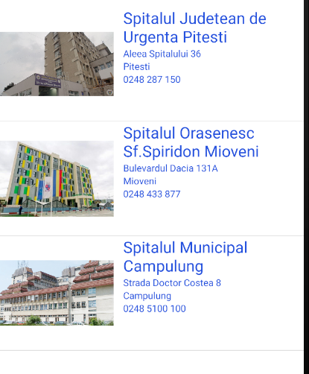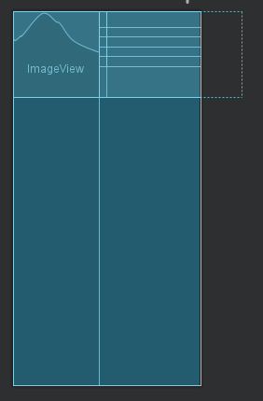Unitatile de testare sunt afisate intr-o lista de forma:

Fig1 Fig 2

Sunt disponibile cate o imagine si cateva date(numele,adresa, orasul, numarul de telefon) despre centrele de testare din Arges. La apasarea fiecarui element , se va deschide o pagina web pentru realizarea programarii la spitalul respectiv(Intent.ACTION_VIEW).

Toate datele sunt salvate in cod prin intermediul vectorilor de tip String(nume,adresa,oras, numar de telefon, id-ul imaginilor, link-urile) si sunt afisate prin intermediul uunei clase “customListView”.

Activity-ul de verificare al rezultatelor este un sistem de login cu un singur camp(CNP) care face legatura cu o baza de date de tip SQLite.

Prin apasarea butonului “LOGIN” programul desfasoara urmatoarele:

Daca CNP-ul exista in baza de date:

* Se preia textul din EditText (CNP-ul);
* Se creeaza un Cursor pentru extragerea datelor din baza de date (se extrag doar numele si numarul de telefon);
* Se deschide un nou Activity in care se transfera datele cerute(Numele, numarul de telefon);

Daca CNP-ul nu exista in baza de date:

* Se afiseaza un Toast cu mesajul corespunzator;

**Baza de date:**

Schema:

|  |  |  |  |
| --- | --- | --- | --- |
| patients_table | | | |
| **ID**(int pk) | **Name**(text) | **CNP**(text) | **Phone**(text) |
|  |  |  |  |

Metoda de extragere a datelor primeste ca parametru un String(CNP) , creeaza un query pentru extragerea datelor persoanei cu CNP-ul respectiv si returneaza un Cursor cu toate datele extrase prin intermediul query-ului.

**Butonul “Unitati sanitare…”:**

Butonul deschide un activity cu lista unitatilor sanitare respective. Elementele listei sunt de forma celei precedente(vezi Fig1), iar datele sunt salvate vectori de String-uri.

Prin apasarea fiecarui buton , se va deschide un activity cu imaginea marita, datele precedente si un buton care prin apasare deschide pagina web a spitalului respectiv.

**Butonul “Chestionar”:**

Prin apasarea butonul se deschide un activity care contine un test cu 5 intrebari. Daca la oricare dintre ele se raspunde cu “DA” atunci , la sfarsit se va afisa un mesaj de avertizare si va aparea un buton de redirectionare catre activity-ul de testare.

Fiecare intrebare se actualizeaza prin intermediul unei functii ce apeleaza metoda din clasa “Intrebari”(getQuestion). Toate intrebarile sunt salvate in clasa “Intrebari” intr-un vector de String-uri.

**Imaginile folosite**

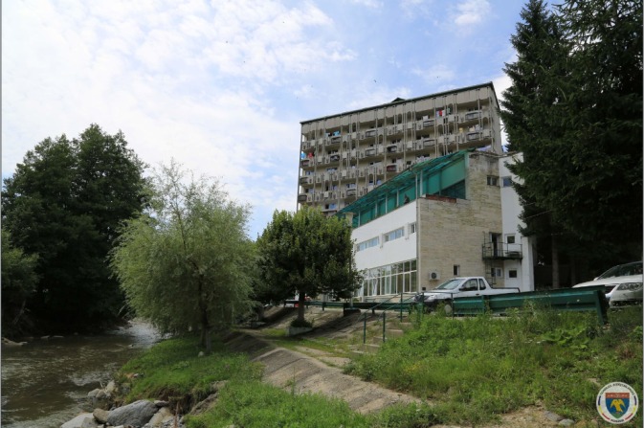(Toate imaginile au fost preluate de pe Google Images)

Spitalul Bradet

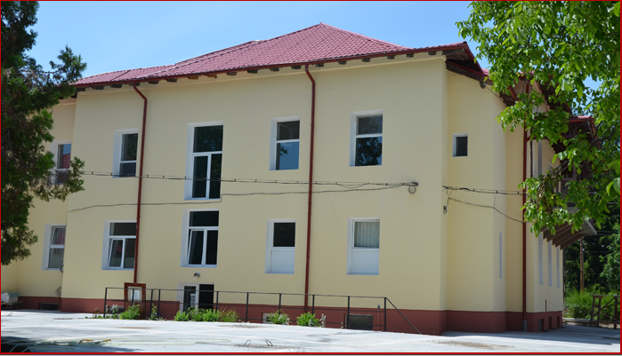

Spitalul Costesti

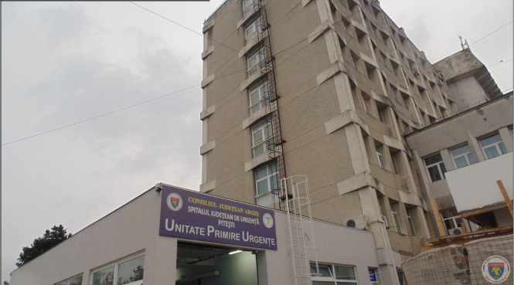

Spitalul Judetean

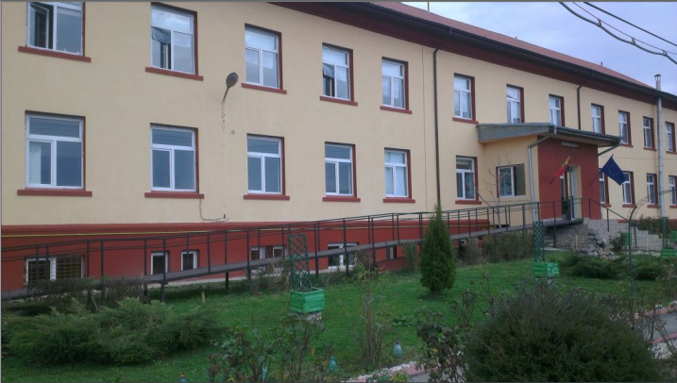Spitalul Leordeni

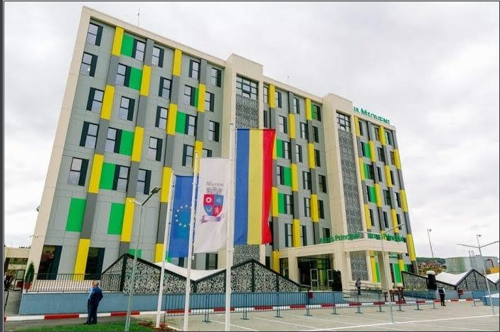Spitalul Mioveni



Spitalul de pediatrie

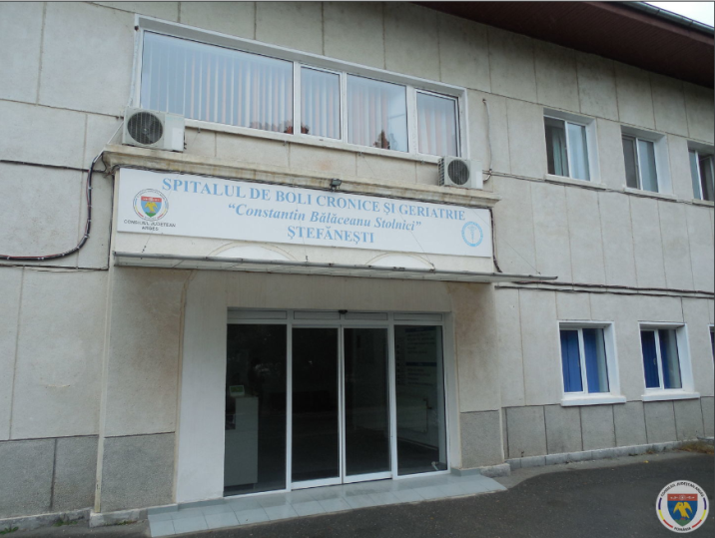Spitalul Stefanesti

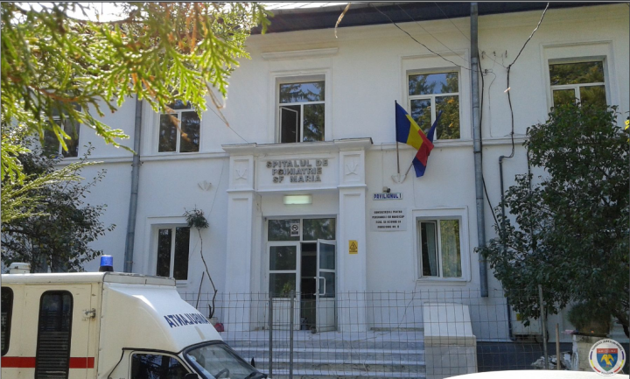Spitalul Vedea

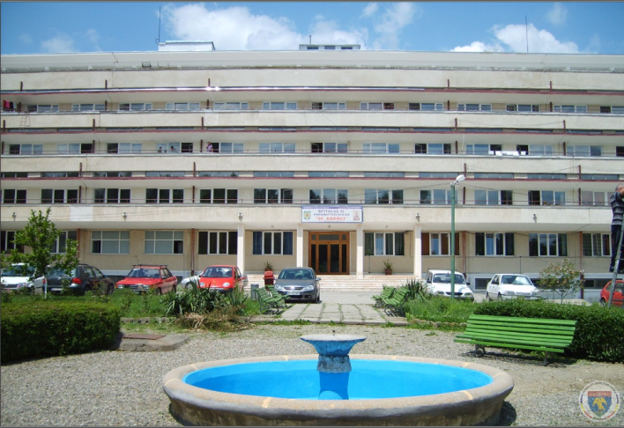

Spitalul Vaslui

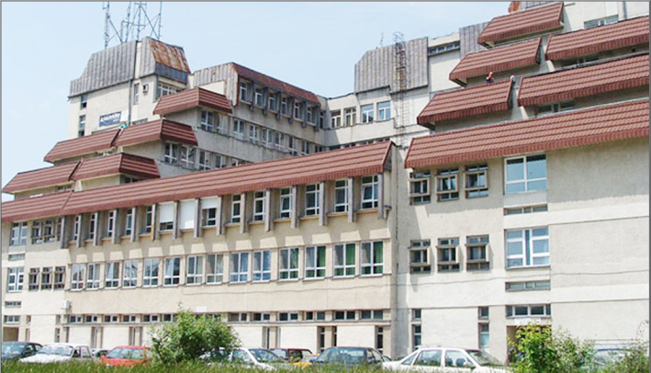

Spitalul Campulung

Toate imaginile au fost preluate de pe Google Images;

Toata functionalitatea a fost realizata cu ajutorul laboratoarelor precedente.